Creating A Placemark in
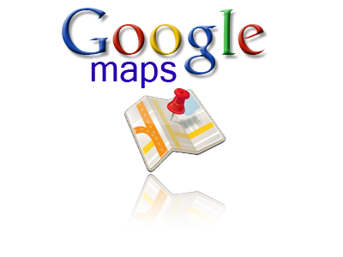

Created by Mr. Biggs for St. Thomas School Technology Lab

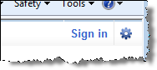
Open the Map
- Sign in.
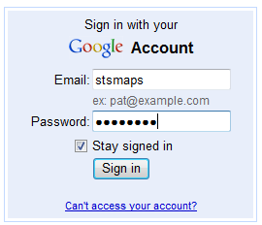
123sts45

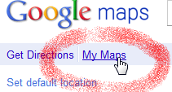
- Click on My Maps.

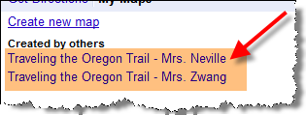
- Click on your class map.

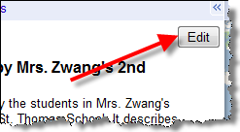
Creating a Placemark
- Click the Edit button.

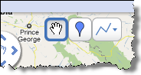
- Three tools will appear on your map.

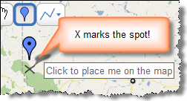
- Click on the balloon tool and drag the placemark out.

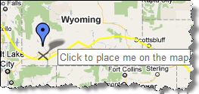
- Click to drop the marker on the right place on the map. Remember, the X marks the spot!

Edit Your Placemark
- Click the Edit button above the map name.
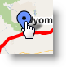
- Click on the balloon on the map or in the list.
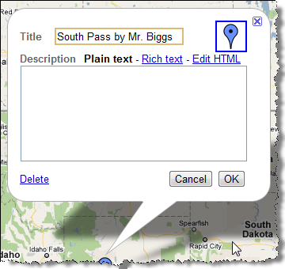
- The placemarker balloon will open.

- Type in the title. Your title should include your placemark and your name.

- Click RICH TEXT. This makes it easier to edit.
- Type in your sentence that explains why this landmark was important.
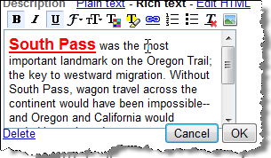
You can use the tools to format the text (make it bold, change size and color, etc.)
- Click OK to save what you are typing!
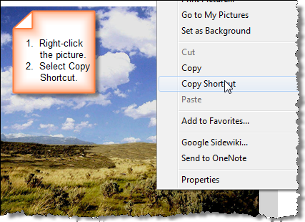
- Now find your picture and copy the SHORTCUT!

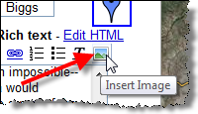
- Click the Insert Image icon to put your picture in the balloon.
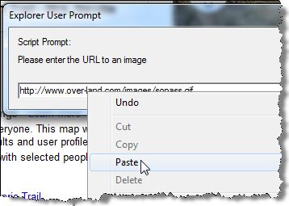
- A small window opens up. Right-click and paste the shortcut (the URL to the picture).

- Your picture will be on the top of the description. Drag it to the bottom (or CUT and PASTE).
- Click OK to finish your placemark.
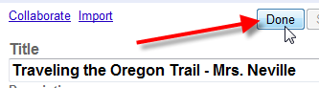
- Click the DONE button above the map name.
Your finished placemark will look like this:
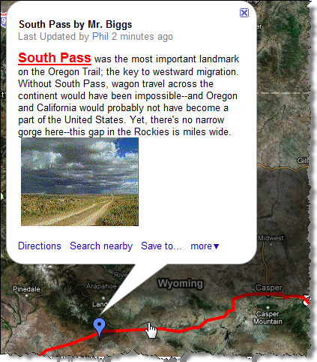
To see other student’s placemarks you might have to SIGNOUT and SIGN IN again.

